**CHAPTER 5**

**EXPERIMENTAL WORK**

**5.1 Experimental Investigation of the Engine Performance Parameters** Experimental engine tests were carried out in the automobile lab of Sri Venkateshwara Engineering Consultancy Services, Kancheepuram, on a CRDI VCR engine arrangement. The various tests were carried out on a single-cylinder, 4-strokes, and water-cooled VCR engine operating at constant speed of 1500 rpm with (cold) EGR or without EGR (Exhaust Gas 21 Recirculation) as indicated in Figure — for conventional diesel and different blends of linseed biodiesel. The various engine specifications are listed in the table — In this experiment, engine performance characteristics such as BP, BSFC, BTE, mechanical efficiency, and BMEP are investigated.

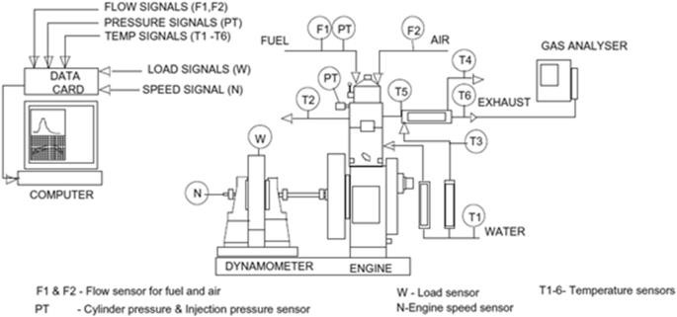

**Figure 5.1 The CRDI diesel engine set up**

**5.1 The technical specifications of the engine setup**

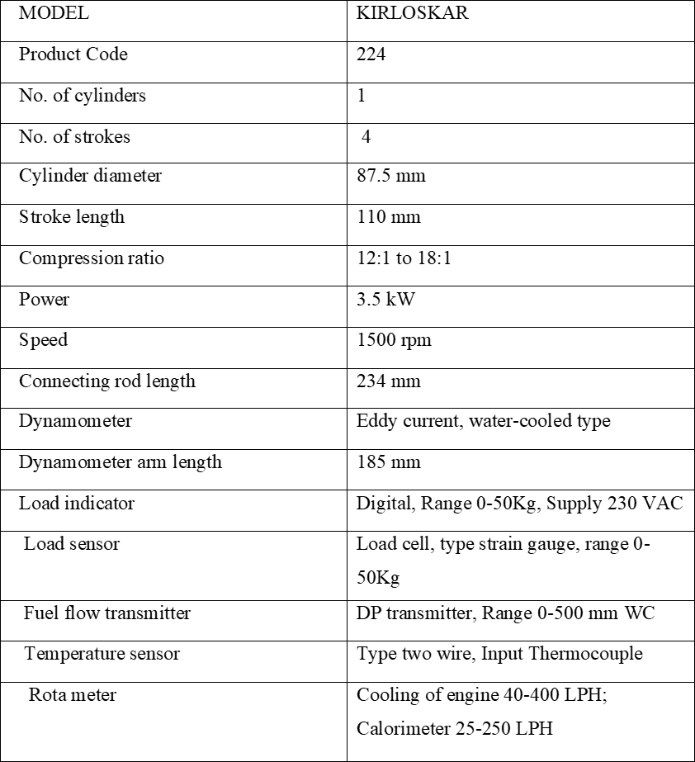

**Table 5.1 The technical specifications of the engine setup**

### 

### 5.2 Eddy Current Dynamometer

There is a link between the engine and the eddy current dynamometer, which primarily measures power and torque. Several weights were applied to the CRDI engine using a dynamometer and a load cell, including 0kg, 3kg, 6kg, 9kg, and 12kg.The load was displayed on the load indicator since it was connected to a load sensor. There is one. A rotor resembles a notch disc and is driven by a prime mover and a stator (magnetic).

Externally, there is a space between the poles. The magnetic poles are energized via a coil that is wrapped circumferentially. The primary mover rotates the rotor and sends voltage to the exciting coil or stator case. As a result, magnetic flux is generated, and the rotor cuts off the magnetic fluxes. As a result, the eddy current generated in the rotor is in opposition to the magnetic flux change.

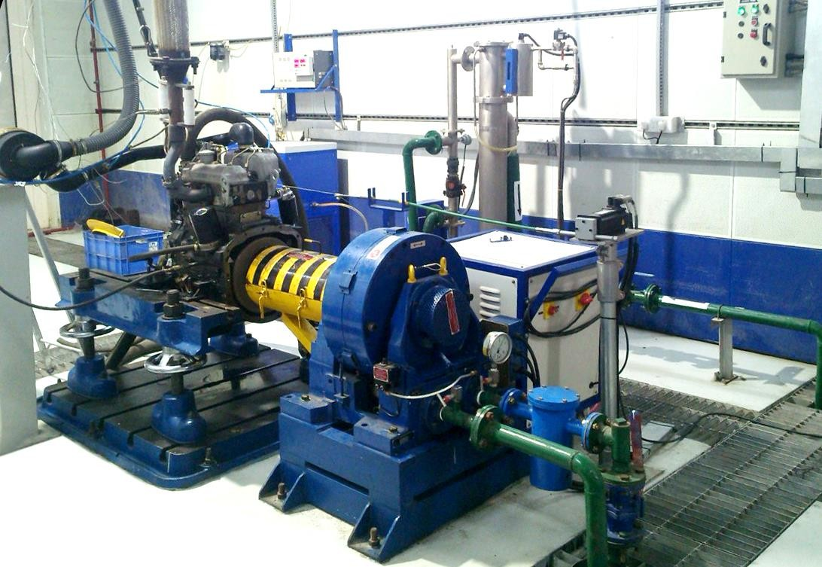

**Figure 5.2 Eddy Current Dynamometer**

### 

### 5.3 AVL Exhaust Gas Analyzer

Figure (5.3) shows how an AVL gas analyzer (AVL DIX 650) measures emission parameters such smoke opacity, CO, NOx, CO2, and UHC. The one end of this system is connected to the gas analyzer, while the other end is connected to the exhaust gas pipe. The gas analyzer's technical specifications are provided in table.

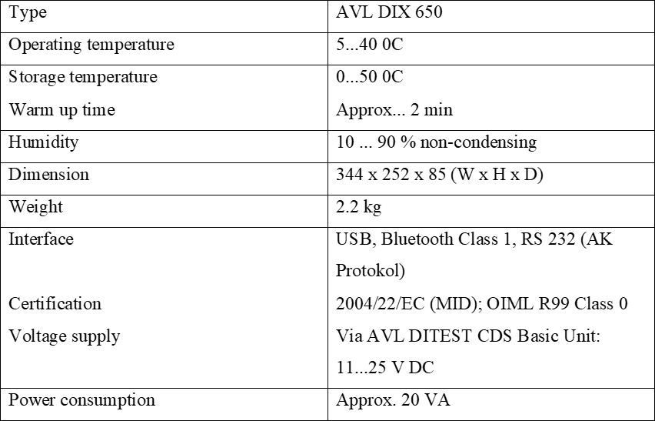

**Table 5.2 The specifications of AVL exhaust gas analyze**

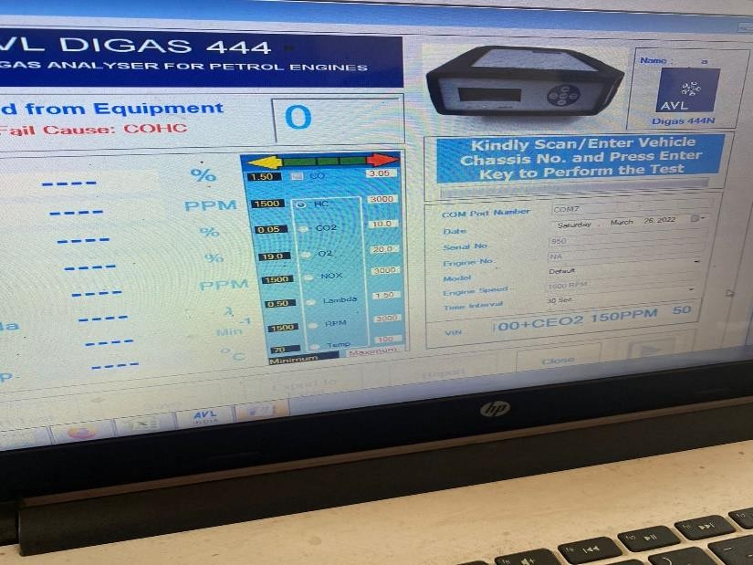

**Figure 5.3: AVL Exhaust Gas Analyzer**

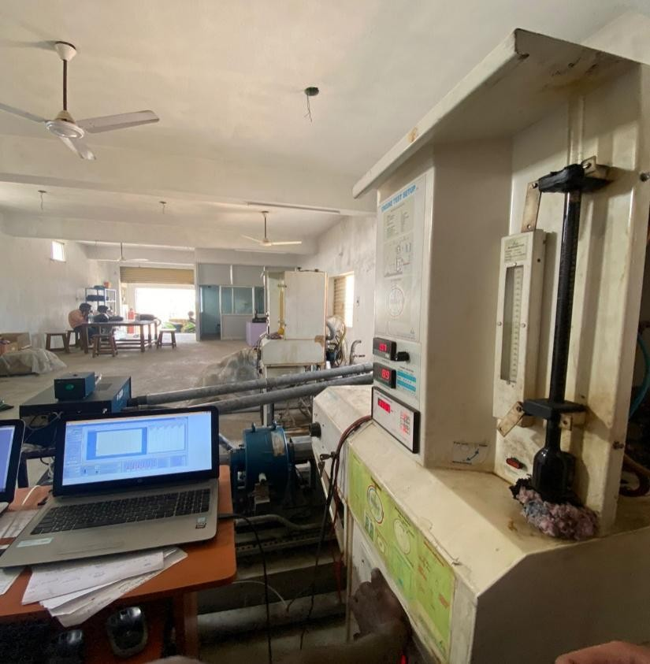

**Figure 5.4: CRDI VCR Engine**

### Experimental Procedure

Initially, the engine was powered by diesel, but it is now powered by CNSL And CNSl+CEO2

The following steps are used for the experiment

* + 1. At first, diesel have become filled in fuel line tank of CRDI VCR engine adjusted with a compression ratio 18:1.
    2. Then the water is provided through the motor. The calorimeter and cooling water go with the flow have become set 75LPH and 150LPH (liter in the line with hour) respectively
    3. Confirmed an appropriate facility for the piezo cooling sensor and eddy current dynamometer.
    4. After that, strictly checked all the electric powered factor and connection provided power to the system
    5. Then diesel became allowed into the engine with the aid of using establishing the knob of the burette.
    6. The gravity and the calorific cost are adjusted via the configure choice gift with inside the software program for the experiment. vii. The engine became adjusted with injection strain at six hundred bar and injection perspective at 230CATDC with the aid of using configuring choice withinside the software program.
    7. At 0 load circumstance, the engine became operated for 10 mins with the aid of using choosing the run choice at the software program.
    8. Pressed the log-on choice proven withinside the software program and permit the diesel supply. The show modified into enter mode and after 1 minute. Thereafter the water flow became entered in calorimeter cooling jackets. Noted the primary analyzing at 0 load circumstance and cost stored withinside the software program with the aid of using creating a file.
    9. After that became the gas knob to the preceding position. xi. The identical steps had been repeated for distinct load i.e., 3kg, 6kg, 9kg, and 12kg. Their corresponding values had been stored withinside the software program.
    10. These above-cited strategies had been repeated for a one-of-a-kind mixture of Linseed biodiesel i.e., CNSL And CNSL+CEO2 through converting the gasoline withinside the tank and additionally the corresponding fee of the gravity and CV had been adjusted therefore in the software.
    11. All those steps observed once more through making use of EGR (14%) this time and values had been Recorded.
    12. After saving all the values similar to one-of-a-kind mixture at one-of-a-kind masses, furnished 0 masses the engine and after that flip off the device and engine.
    13. After some minutes, the water deliver changed into stopped too.

The following precautions are taken during the experiment:

* + - 1. All the joints' elements like nut and bolt have been checked strictly and it need to be tight earlier than running the engine.
      2. The availability of gas withinside the gas line and the gas tank ought to be sufficient.
      3. Proper cleansing of the flue line and gas tank to do away with the impurities.
      4. The motor for the water delivers became on earlier than beginning the device for cooling.
      5. Sensor and touchy device surpassed carefully.

The following steps were taken for evaluation of emission parameters:

1. When the engine became set on a selected load for a selected mixture then placed the fuel line analyzer sensor within the exhaust pipe of the engine.
2. The exhaust gases exceeded thru sensors and readings had been displayed on the virtual screen.
3. When the information is stabilized, three next values had been taken and their Mean price became stated for evaluation purposes.
4. The exhaust pipe then eliminated from the sensor.
5. These steps had been repeated for distinctive blends at distinctive

load conditions.

1. Their corresponding readings had been stated accordingly.

**CHAPTER 6**

**RESULTS & DISCUSSIONS**

Combustion parameters:

Gas Specification (Kilojoules / kg): 1.00, Air Density (kg / m3): 1.17, Adiabatic Index: 1.41, Multi-Feed Index: 1.10, Cycle Count: 10, Cylinder Pressure Reference: 6, Smoothing 2, TDC

Performance Parameters:

Orifice Diameter (mm): 20.00, Orifice Coeff. Of Discharge: 0.60, Dynamometer Arm Length (mm) : 185, Fuel Pipe die (mm) : 12.40, Ambient Temp. (Deg C) : 27, Pulses Per revolution : 360, Fuel Type : Diesel, Fuel Density (Kg/m^3) : 890, Calorific Value of Fuel (kg./kg) : 37223

**6.1 Performance & Combustion**

**Characteristics Diesel**

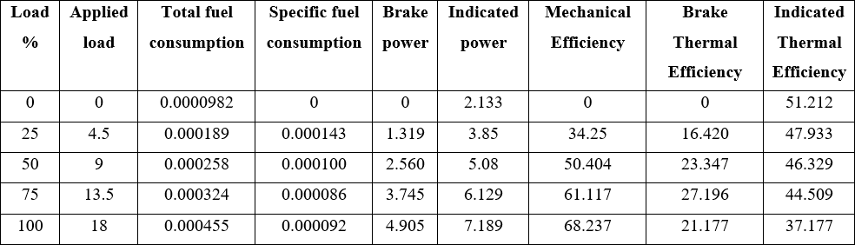

**Table 6.1 Performance & Combustion Characteristics of Diesel**

**CNSL**

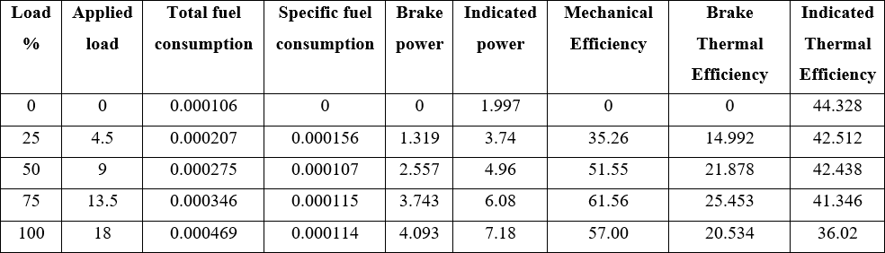

**Table 6.2 Performance & Combustion Characteristics of CNSL**

**CNSL + Al2O3**

**Table 6.3 Performance & Combustion Characteristics of CNSL + Al2O3**

**Brake Power vs Brake Thermal Efficiency**

**CHAPTER 7**

**CONCLUSION**

The performance and emission characteristics of a compression ignition diesel engine using a mixture of diesel, TC CNSL and TC CNSL + CeO2 have been experimentally tested and the following results have been obtained.

* Diesel IP is 6.2% higher than TC CNSL and TC CNSL + CeO2.
* TFC of TC CNSL is 3% higher and TC CNSL + CeO2 7.7% higher than diesel under full load conditions.
* S SFC of TC CNSL is 19.3% higher and TC CNSL + CeO2 is 8% higher than diesel under full load conditions.
* TC CNSL's brake thermal efficiency is 3% lower and TC CNSL + CeO2 is 62% higher than diesel under full load conditions.
* CO CO2 emissions in TC CNSL are 53% higher and in TC CNSL + CeO2 72% higher than diesel under full load conditions.
* CO2 emissions are similar to diesel and TC CNSL, but TC CNSL + CeO2 contains 4.6% more CO2 emissions than diesel under full load conditions.
* H HC emissions are the same for both diesel and TC CNSL + CeO2, but TC CNSL has 5.7% more HC emissions than diesel under full load conditions.
* N NOx emissions in TC CNSL are 24% lower and in TC CNSL + CeO2 30% lower than diesel under full load conditions.

**Future Scope**

Compared to diesel, the biodiesel blends tested have shown better performance and lower emissions. As a result, the TC CNSL + CeO2 biodiesel mixture can be used as an alternative fuel in diesel engines with a mole ratio of 150 ppm of CeO2.

* The government should implement a simple and cost-effective method for producing biodiesel.
* The blend's long-term stability should be investigated because the mixes developed for this investigation were employed in a short period of time.
* Further technological research and progress on other parameters like as wear and tear analysis, fuel injection timing, and crank angle are required for full combustion of biodiesel in CI engines.

## REFERENCES

1. Gavhane R.S.; Kate A.M.; Soudagar; Wakchaure V.D.; Balgude S; Rizwanul Fattah I.M.; Nik-Ghazali N; Fayez H.; Khan T.M.Y.; Mujtaba M.A.; et al. Influence of Silica Nano-Additives on Performance and Emission Characteristics of Soybean Biodiesel Fueled Diesel Engine. Energies 2021,14, 1489.
2. Ashok Kumar, K. Rajan, M. Rajaram Narayanan, and K. R. Senthil Kumar; et al. Experimental study of diesel engine using cashew nutshell oil (CNSO) with varying injection pressures. AIP Conference Proceedings 2039, 020058 (2018); Doi: 10.1063/1.5079017
3. H. N. Dike, A. Dosunmu, B. Kinigoma and O. Akaranta; Characterization of Chemically Modified Cashew Nut Shell Liquid. Journal of Engineering Research and Reports, 8(4): 1-8, 2019; Article no.JERR.52884, ISSN: 2582-2926
4. Michael G. Bidir, N.K. Millerjothi, Muyiwa S. Adaramola, Ftwi Y. Hagos; The role of nanoparticles on biofuel production and as an additive internary blend fuelled diesel engine: A review, Energy Reports 7 (2021) 3614–3627
5. U. S. Jyothi, G. Jeevan Kumar; Impact of Nano additives on optimized Mahua Bio- diesel Performance, E3S Web of Conferences 184, 01015 (2020)
6. Prabu A. Nanoparticles as additive in biodiesel on the working characteristics of a DI diesel engine. Ain Shams Eng J (2017)
7. G. Kasiraman, V. Edwin Geo b, B. Nagalingam et al. / Energy 101 (2016) 402e410, doi: 10.1016/j.energy.2016.01.086
8. S. Vedharaj, R. Vallinayagam, W.M. Yang, C.G. Saravanan, W.L. Roberts et al. / Experimental Thermal and Fluid Science 70 (2016) 316–324
9. M. Sawadogo, S. Tchini Tanoh, S. Sidibé, N. Kpai, I. Tankoano, Cleaner production in Burkina Faso: Case study of fuel briquettes made from cashew industry waste, Journal of Cleaner Production (2018), doi: 10.1016/j.jclepro.2018.05.261
10. S.K. Sanjeeva, Mitchell Preetham Pinto, Manoj Mulakkapurath Narayanan, Gopalakrishna Mangalore Kini, Chandrasekhar Bhaskaran Nair, P.V. SubbaRao, Phani Kumar Pullela, Siva Ramamoorthy , Colin J. Barrow et al. / Renewable Energy 71 (2014) 81e88, doi: 10.1016/j.renene.2014.05.024
11. Senthil Kumar M, Ramesh A, Nagalingam B. Use of Hydrogen to enhance the performance of a vegetable oil fuelled compression ignition engine. J Hydrogen Energy 2003;28(10):1143e54.
12. Campos Fernandez Javier, Arnal Juan M, Jose Gomez M, Dorado Pilar. A comparison of performance of higher alcohols/diesel fuel blends in a diesel engine. Appl Energy 2012;95:267e75.
13. Holman JP. Experimental techniques for engineers. 7th ed. New Delhi: Tata McGraw Hill; 2004.
14. Hazar Hanbey, Aydin Huseyin. Effect of ethanol blending with biodiesel on engine performance and exhaust emissions in a CI engine. Appl Therm Eng 2010;30:1199e204.
15. Soudagar, M.E.M.; Banapurmath, N.; Afzal, A.; Hossain, N.; Abbas, M.M.; Haniffa, M.A.C.M.; Naik, B.; Ahmed, W.; Nizamuddin, S.; Mubarak, N. Study of diesel engine characteristics by adding nano-sized zinc oxide and diethyl ether additives in Mahua biodiesel–diesel fuel blend. Sci. Rep. 2020, 10, 1–17.
16. Shahir, S.; Masjuki, H.; Kalam, M.; Imran, A.; Fattah, I.R.; Sanjid, A. Feasibility of diesel–biodiesel–ethanol/bioethanol blend as existing CI engine fuel: An assessment of properties, material compatibility, safety, and combustion. Renew. Sustain. Energy Rev. 2014, 32, 379–395
17. Hoseini, S.; Najafi, G.; Ghobadian, B.; Ebadi, M.; Mamat, R.; Yusaf, T. Performance and emission characteristics of a CI engine using graphene oxide (GO) nano-particles additives in biodiesel-diesel blends. Renew. Energy 2020, 145, 458– 465.
18. Basha, J.S. An Experimental Analysis of a Diesel Engine Using Alumina Nanoparticles Blended DIESEL fuel; 0148-7191; SAE Technical Paper; SAE International: Warrendale, PA, USA, 2014.
19. Sayin, C.; Ilhan, M.; Canakci, M.; Gumus, M. Effect of injection timing on the exhaust emissions of a diesel engine using diesel–methanol blends. Renew. Energy 2009, 34, 1261–1269.
20. Akinhanmi TF, Atasie VN. Chemical composition and physicochemica properties of cashew nut (Anacardium occidentale) oil and cashew nut shell liquid. J Agric Food Environ Sci 2008;2:1–10.